Git Notes

This is for adding a list of files together
- Git status – gives the list of files that are yet to be committed.

The green ones are new files and red are modified files
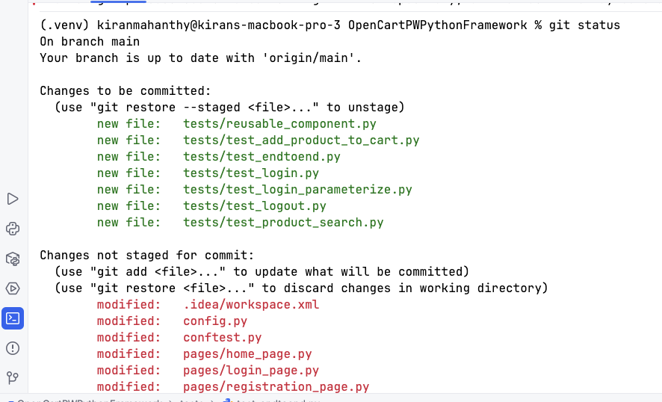

- git add -u

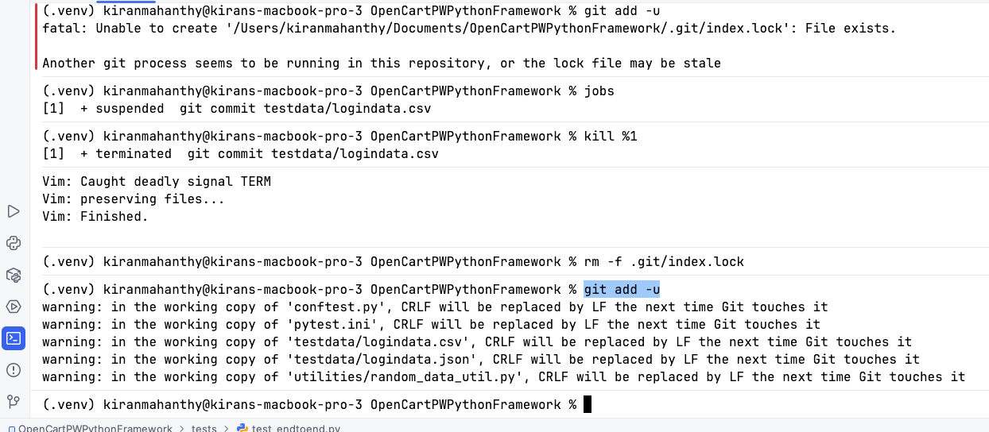

- git status

All the file changes to green.

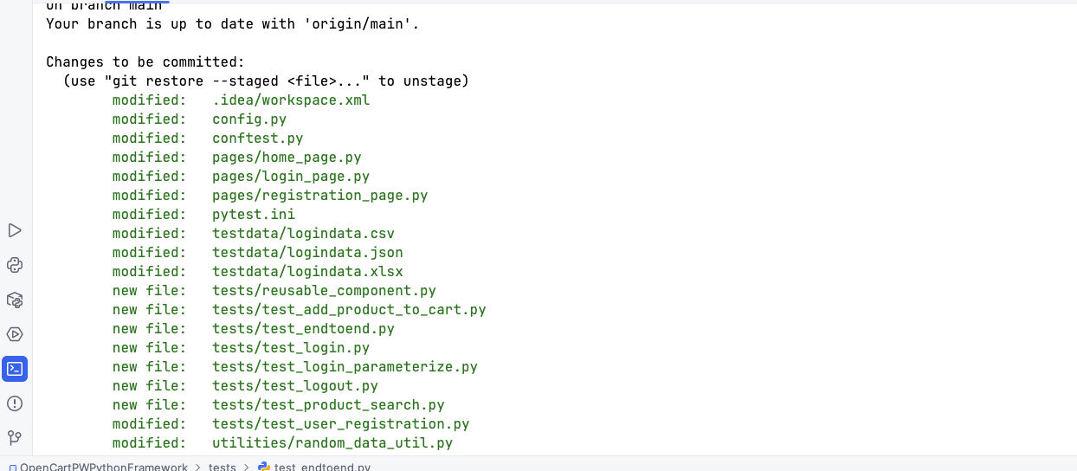

- git commit -m "Updated automation framework and test cases"

Note: untracked files are not committed to git.
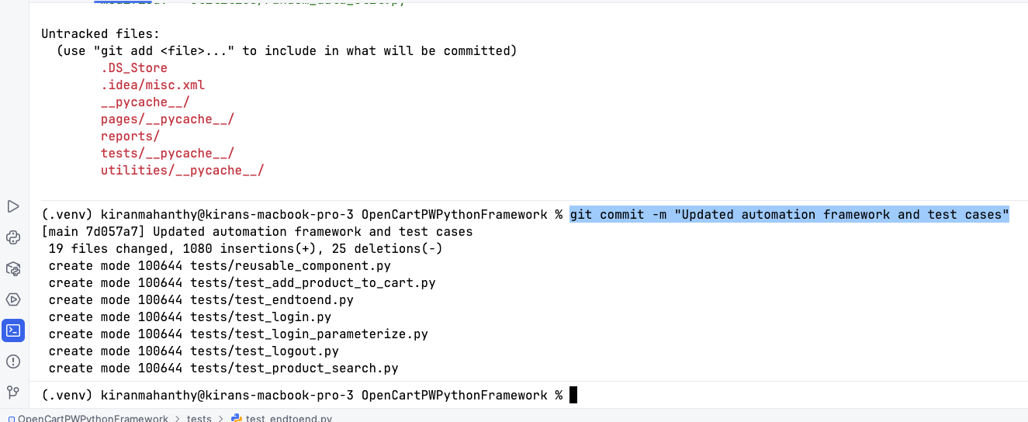

- git status
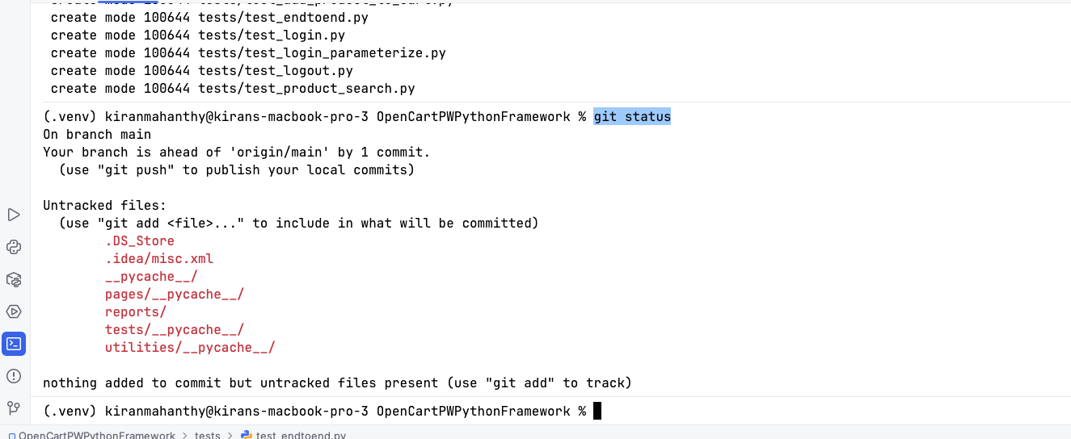

- git push origin main

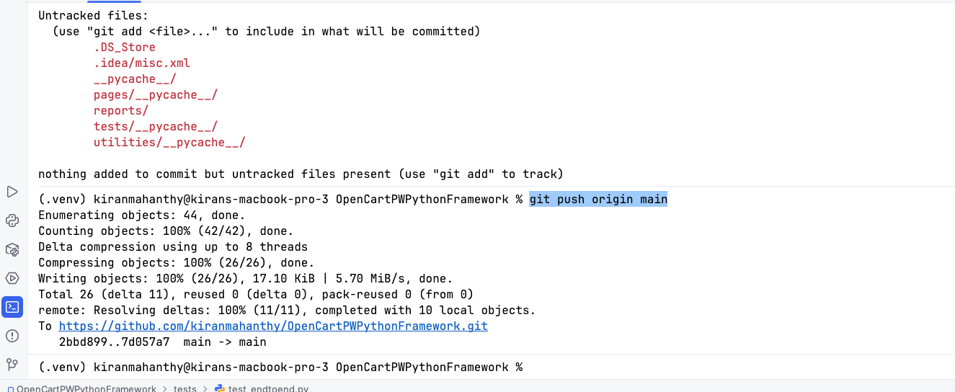

Adding a single file now.

Steps:
- git add "Git Notes - Step by Step.docx"
- git status
- git commit -m "Added Git step by step notes"
- git push origin main

** These steps need to be repeated when there is a modification to the existing file.
